**HALL TICKET NUMBER: 2403A51311**

**NAME: M.Varsha**

**BATCH: 24BTCAICSB13**

**TASK 1:**

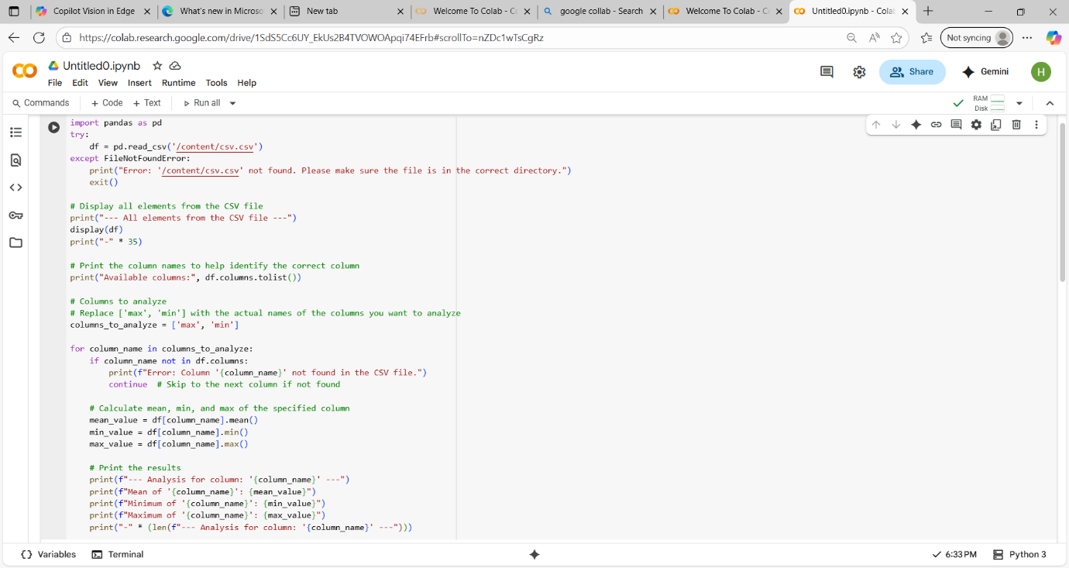

OTUPUT:-

**TASK 2:**

**Gemini:-**

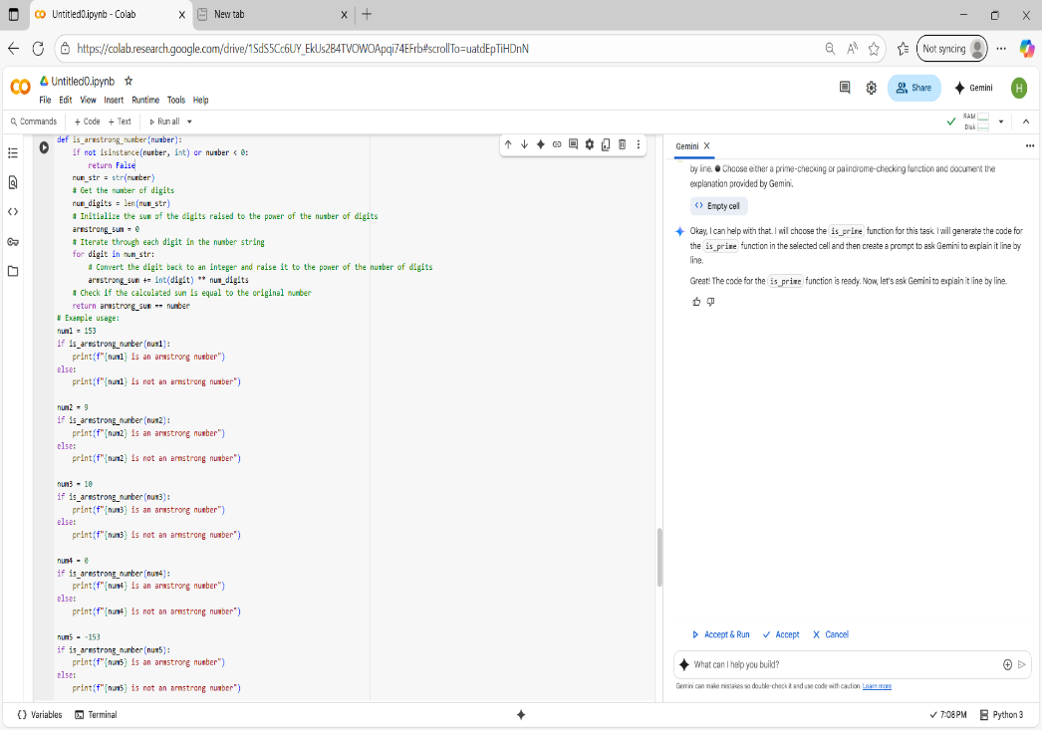

OTUPUT:-

Copilot:-

Observation Table:-

| **Feature** | **Gemini** | **Copilot** |
| --- | --- | --- |
| **Code size** | Short and minimal | Longer with more lines |
| **Execution time** | About 2 seconds | Around 3 seconds |
| **Speed of response** | Quick and snappy | Takes more time to respond |
| **Result accuracy** | Delivers correct results | Delivers correct results |
| **Code style** | Simple and easy to read | More detailed, sometimes verbose |
| **Explanation detail** | Brief notes | Provides extra context in code |
| **Performance** | Optimized for small tasks | Handles larger, complex code better |
| **Efficiency** | Uses fewer resources | May use slightly more resources |

TASK:3

TASK:4

Cursor ai:-

OUTPUT:-

Gemini:-

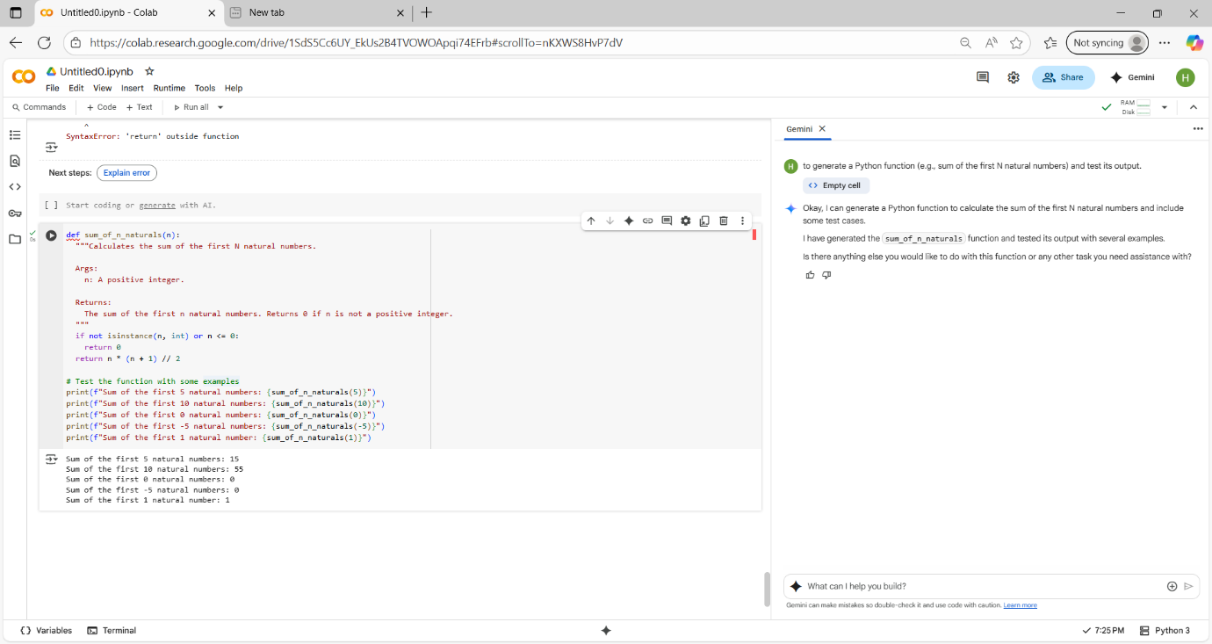

TASK:5

Student code:-

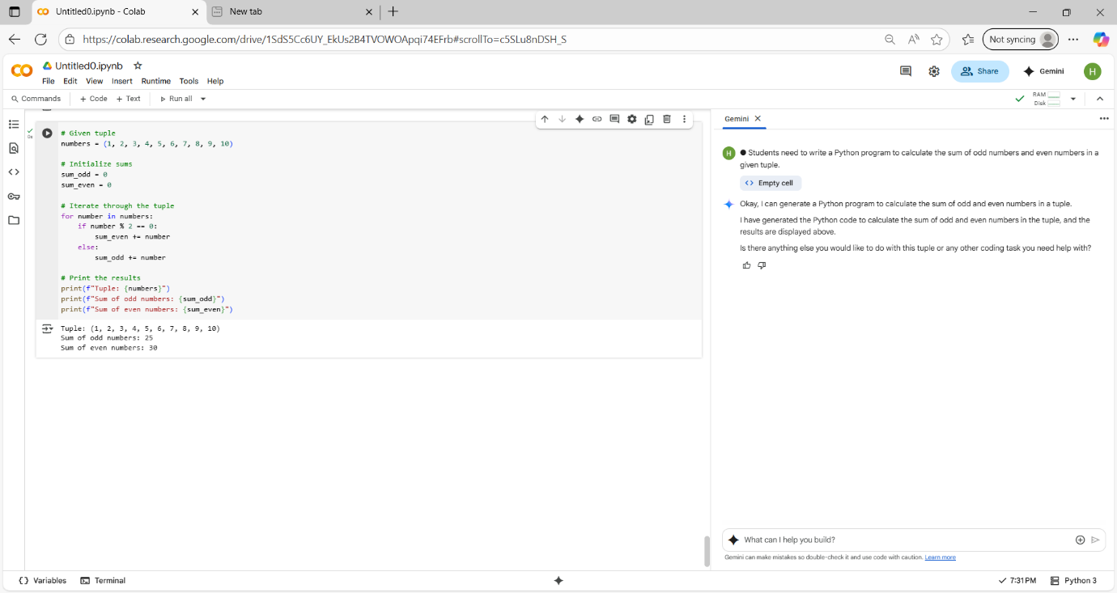

Refactored code:-

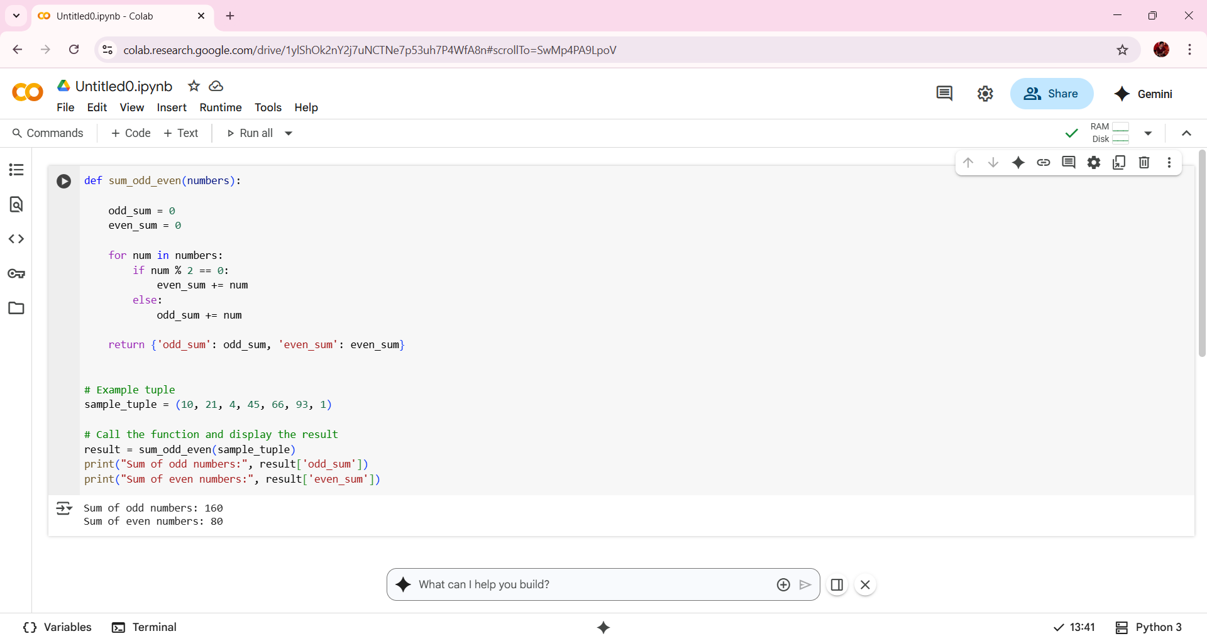

**Explanation of Refactoring**

* Function Encapsulation: Wrapped the logic inside a function sum_odd_even() for reusability and modularity.
* Descriptive Variable Names: Used odd_sum and even_sum for clarity.
* Dictionary Return: Returning a dictionary makes the result easy to access and extend.
* Docstring: Added a docstring to explain the function’s purpose and usage.